Whimple School Survey

Disability Equality – Involving You

At Whimple Primary School and Whimple Pre-School we want to make sure that everyone who has an interest in the school feels part of the school community – parents, carers, pupils, governors, staff, visitors – and has equality of opportunity and equality of access.

Equality is when we treat people fairly and according to their needs so that they experience a fair or equal outcome or level of satisfaction. It’s not about treating everyone the same.

Providing ‘equality’ is not just about having ‘ramps and handrails’. It can mean, for example, making sure that all children can take part in school trips or sports day, or making sure that reading books include positive images of people with disabilities.

If you have a disability you may have difficulties accessing information, events or facilities the school provides. Some people with disabilities experience prejudice and poor attitudes because of their disability (for example, people do not talk to them, or perhaps don’t take the extra time needed to help or explain something). We hope this doesn’t happen at Whimple…


We want to know if we can do more to help and make sure that you have equal access and opportunities when you come into contact with the school and that we are doing our best to promote disability equality and awareness.

Image taken from Disability Rights Commission website.

If you need this information in a different format, more forms, or other help, please contact us.

What’s a disability?

A disability can be:

- Physical (for example difficulties moving, using a wheelchair)
- Sensory (for example a visual impairment, Blind, hearing impairment or Deaf)
- Mental (for example depression or a brain injury)
- Learning disability
- Long term illness or health condition (for example MS, cancer, HIV, epilepsy, diabetes)
- It also includes dyslexia, speech problems and disfigurements.

A disability can affect ‘normal day to day activities’.

What are we asking?

We would like to know two things:

- If there’s anything we do well for people with disabilities (for example, are our buildings accessible?).
- If there’s anything we can do better for people with disabilities.

This is an anonymous survey and we don’t need to know your name unless you want to get involved further.


What will we do with the information?

We will use the feedback you give us to improve our Disability Equality Scheme. The scheme will include information about what we do, or will do, to ensure equality for people with disabilities. If there are things we can do better then we will put these into an action plan so that we can make improvements over time…we won’t be able to do everything over-night!

Any personal information you provide will be dealt with in confidence and will only be reviewed by the staff and governors in order to develop and improve the Scheme. We will not make this information available to anyone else, nor will we refer to personal issues within the Disability Equality Scheme. We hope you feel able to provide as much information you feel is relevant.

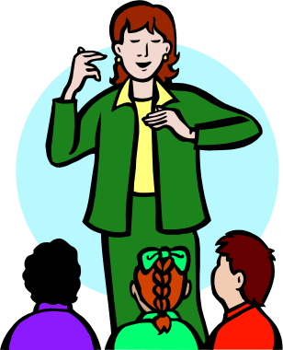
How can I get involved?

There are a number of ways you can give us feedback:

Everyone -
- Please complete the questionnaire.

Parents/carers –
By letter, telephone or appointment if you have an issue you do not wish to disclose on the questionnaire

Pupils –
- Tell your School Council Rep.
- We will also include this in PSHE lessons

Governors –
- Contact head teacher

Staff –
- As an item during Staff Review Meetings

Or, if none of these are suitable you can arrange an appointment with the Head teacher, Mrs Jessop.

If you need to tell us in another way, please let us know and we will be happy to try and accommodate. Please contact the School Office.

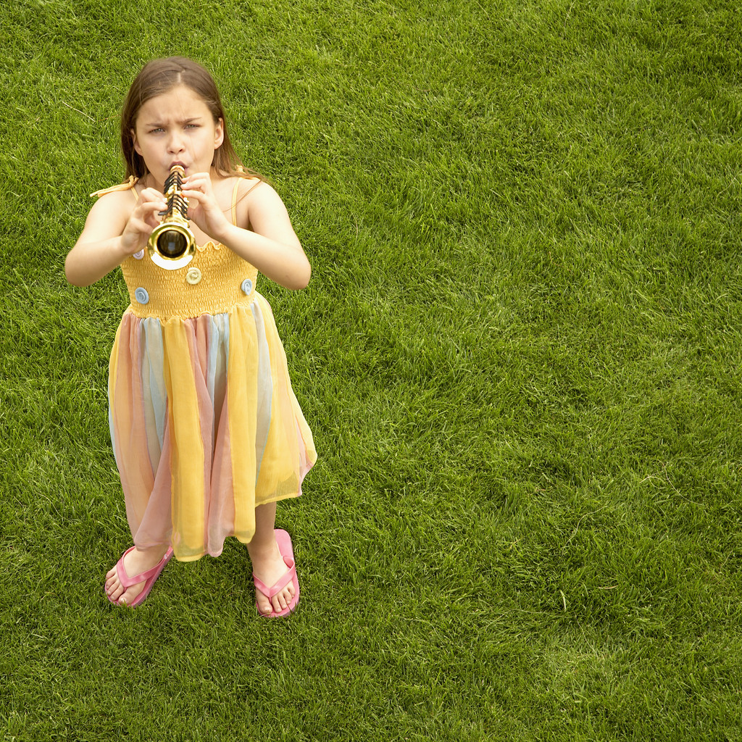

Disability Survey Questionnaire

-Please complete your questionnaire or give feedback by 13th November 2015.
-Please hand your completed questionnaire in to the School Office or, if you prefer, you can complete an electronic version, available on the school website.
-You may provide any additional information on a separate sheet.
If you require an envelope for your questionnaire, please ask at the Office.

Your views

Please think about all aspects of school life when answering the questions in the disability survey. You may have views on (for example):

Newsletters or other information provided by the school.

Parents’ meetings.

Events.

School website.

Policies and procedures.

Learning and education.

Extra-curricular activities.

Visits.

Materials and equipment.

Employment.

Governors.

Catering.

Buildings and environment, including parking, playgrounds.

Pre-school and school clubs.

Ways of contacting or communicating with the school.
Whimple School would like to acknowledge Starcross Primary who developed the original format for this survey material.

